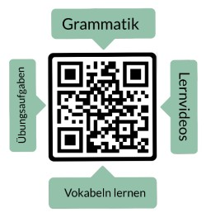**Prueba de vocabulario: “Sich vorstellen Block 1”**

**Nombre: ______________________**

Instrucciones: Traduce la palabra alemana al español.

|  |  |  |
| --- | --- | --- |
| **alemán** | **español** | **puntos** |
| **der Name** |  | 1 |
| **das Alter** |  | 1 |
| **die Adresse** |  | 1 |
| **die Telefonnummer** |  | 1 |
| **die E-Mail-Adresse** |  | 1 |
| **der Beruf** |  | 1 |
| **die Nationalität** |  | 1 |
| **die Hobbys** |  | 1 |
| **die Familie** |  | 1 |
| **die Freunde** |  | 1 |
| **die Schule** |  | 1 |
| **die Universität** |  | 1 |

puntos: _____ / 12

nota: _________________________

firma: __________________________________

|  |  |  |  |  |  |
| --- | --- | --- | --- | --- | --- |
| sehr gut | gut | befriedigend | ausreichend | mangelhaft | ungenügend |
| 12-11,5 | 11-10 | 9,5-8 | 7,5-6 | 5,5-3 | 2,5-0 |